**PNEUMONIA DETECTION USING CONVOLUTIONAL NEURAL NETWORKS**

# MINI PROJECT REPORT

***Submitted by***

**Sathya S–111718104085**

**Thyagaraj T–111718104101**

**Yanamadala Vasu Deva Sai–111718104116**

***In partial fulfillment for the award of the degree***

***Of***

## 

## BACHELOR OF ENGINEERING

**in**

### COMPUTER SCIENCE AND ENGINEERING

**R.M.K. ENGINEERING COLLEGE, KAVARAIPETTAI**



**ANNA UNIVERSITY CHENNAI 600 025**

**APRIL 2021**

**ANNA UNIVERSITY: CHENNAI 600 025**

**BONAFIDE CERTIFICATE**

Certified that the mini project report “**Pneumonia Detection Using Convolutional Neural Networks”** is the bonafide work of “**Sathya S(111718104085), Thyagaraj T(111718104101) and Yanamadala Vasu Deva Sai(111718104116) ”**, who carried out the project under my supervision.

|  |  |
| --- | --- |
| **SIGNATURE** | **SIGNATURE** |
| **Dr. T. SETHUKARASI, M.E., M.S., Ph.D., PROFESSOR AND HEAD OF THE DEPARTMENT,**  Department of Computer Science and Engineering,  R.M.K. Engineering College,  R.S.M. Nagar, Kavaraipettai - 601206. | **DR. SANDRA JOHNSON M.E,Ph.D, PROFESSOR**  Department of Computer Science and Engineering,  R.M.K. Engineering College,  R.S.M. Nagar, Kavaraipettai -601206. |

Submitted for the mini project viva voice held on …………………………………….……. at R.M.K. Engineering College, Kavaraipettai-601 206.

### INTERNAL EXAMINER EXTERNAL EXAMINER

**ACKNOWLEDGEMENT**

We earnestly portray our sincere gratitude and regard to our beloved Chairman **Shri. R. S. Munirathinam**, our Vice Chairman,**Mr. R. M. Kishore** and our Director, **Shri. R. Jyothi Naidu**, for the interest and affection shown towards us throughout the course.

We convey our sincere thanks to our Principal, **Dr.K.A.Mohamed Junaid**, for being the source of inspiration in this college.

We reveal our sincere thanks to our Professor and Head of the Department, Computer Science and Engineering, **Dr. T. Sethukarasi**, for her commendable support and encouragement for the completion of our project.

We would like to express our sincere gratitude for our mini project coordinators **Ms.T.C.Jermin Jeaunita, Dr. A.V. Kalpana and Ms. N.Banupriya**, for their valuable suggestions towards the successful completion for this project in a global manner.

We take this opportunity to extend our thanks to all faculty members of Department of Computer Science and Engineering, parents and friends for all that they meant to us during the crucial times of the completion of our project.

Sathya S(111718104085)

Thyagaraj T(111718104101)

Yanamadala Vasu Deva Sai(111718104116)

**ABSTRACT**

Pneumonia is an infection in the lungs that inflames the air sacs in one or both lungs. It is caused by a bacteria called Streptococcus pneumonia that normally lives in the upper respiratory tract. More than 10 million people in India are affected by this annually. Chest X-ray is used by doctors to confirm the infection and its location. Thus developing an automatic system for detecting the infection can help to treat the patients quickly. With the powerful Artificial Intelligence algorithms, the medical field has evolved in a very vast manner. Deep Learning Convolutional Neural Networks (CNN) is the go-to algorithm when it comes to image classification. CNN models are so powerful that they are already in use for many disease detections. CNN models can be used to analyze and find patterns in the images. We build a CNN model to analyze the patterns in the given X-ray image and predict the patient is infected or not.

**TABLE OF CONTENTS**

|  |  |  |
| --- | --- | --- |
| **CHAPTER**  **NO** | **TITLE** | **PAGE NO** |
|  | **ACKNOWLEDGEMENT** | **3** |
|  | **ABSTRACT**  **LIST OF FIGURES** | **4**  **6** |
| **1** | **INTRODUCTION**   * 1. Problem Statement   2. Objective   3. Project scope | **7** |
| **2** | **SYSTEM IMPLEMENTATION**  2.1 System Specification  2.2 Software and Hardware description | **8** |
| **3** | **METHODOLOGY**  3.1 Block Diagram  3.2 Functioning and Methodology | **14** |
| **4** | **IMPLEMENTATION AND RESULTS**  4.1 Implementation  4.2 Results | **16** |
| **5** | **CODE SNIPPET**  5.1 PYTHON CODE FOR CNN MODEL  5.2 FLASK APP - PYTHON  5.3 HTML  5.4 JAVASCRIPT  5.5 CSS | **19** |
| **6** | **CONCLUSION & FUTURE ENHANCEMENT** | **34** |
|  |  |  |
|  | **REFERENCES** | **35** |

|  |  |  |
| --- | --- | --- |
| **CHAPTER**  **NO** | **LIST OF FIGURES**  **TITLE** | **PAGE NO** |
| **1.** | **Fig 1: Block Diagram – Web Application** | **14** |
| **4.** | **Fig 2: Index Page – Web Application** | **16** |
| **4.** | **Fig 3: Image Preview and Result(1)– Web application** | **17** |
| **4.** | **Fig 4: Image Preview and Result(1)– Web application** | **18** |

**CHAPTER 1**

1. **Introduction**
   1. **Problem Statement**

To develop an Artificial Intelligence Project which can analyze and detect the presence of the pneumonia disease. The result can be used to give the patients quick and efficient treatment.

* 1. **Objective**

The project aims to design a simple python web-based application which inputs the chest X-ray scan of the patient, store it and the saved model predicts the result and the result is displayed to the user.

* 1. **Project scope**

The primary diagnosis for pneumonia is by taking a Chest X-ray of the patient. However, examining chest X-rays is not a relaxed and easy-going task. In the images, pneumonia can be hazy and can be misapprehended with other diagnoses like lung scarring, congestive heart failure, and many more. This can lead to misclassification or wrong detection of pneumonia in a patient or the worst case not be diagnosed as pneumonia itself when it is present. With more safety and precautionary measures to be undergone by the doctors, the time spent attending a patient becomes very less. In the less time available for the physicians to attend to the patients, the former has to check the latter’s reports and scans and has to diagnose the disease or disorder. Wrong diagnoses can lead to loss of life. Thus the task of detecting the presence of pneumonia from X-ray images is challenging and modeling an algorithm that can detect the presence of thoracic disease like pneumonia will save a lot of time and doctors can quickly start to treat the patients accordingly.

**CHAPTER 2**

1. **System Implementation**
   1. **System Specifications**
      1. **Software requirements**
2. **Python**

Python is widely used for artificial intelligence, with packages for several applications including General AI, Machine Learning, Natural Language Processing and Neural Networks. The application of AI to develop programs that do human-like jobs and portray human skills is Machine Learning. Both Artificial Intelligence and Machine Learning are closely connected and are being used widely today.

1. **HTML (Hypertext markup Language)**

Hypertext Markup Language (HTML) is the set of markup symbols or codes inserted into a file intended for display on the Internet. The markup tells web browsers how to display a web page's words and images.

1. **CSS (Cascading Style Sheets)**

Cascading Style Sheets (CSS) is a style sheet language used for describing the presentation of a document written in a markup language such as HTML. CSS is designed to enable the separation of presentation and content, including layouts, colors and fonts.

1. **JS (Java Script)**

JavaScript**(**JS**)** is a lightweight, interpreted, compiled programming language with first class functions. While it is most well-known as the scripting language for Web pages. JavaScript is a prototype based multi-paradigm, single-threaded, dynamic language, supporting object-oriented, imperative, and declarative (e.g. functional programming) styles.

1. **Anaconda IDE**

Anaconda is a distribution of the Python and R programming languages for scientific computing (data science, machine learning applications, large-scale data processing, predictive analytics, etc.), that aims to simplify package management and deployment. The distribution includes data-science packages suitable for Windows, Linux, and macOS.

* + 1. **Hardware requirements**

1. OS: Windows 10 - 64bit
2. Hard disk : 1TB
3. RAM : 8GB
4. Processor: Intel CORE i5 x64 Processor
   1. **SOFTWARE DESCRIPTION**
      1. **PYTHON**

Artificial intelligence is considered to be the trending technology of the future. Already there are a number of applications made on it. Due to this, many companies and researchers are taking interest in it. There are various programming languages like Lisp, Prolog, C++, Java and Python, which can be used for developing applications of AI. Among them, Python programming language gains a huge popularity and the reasons are as follows −

**Simple syntax & less coding**

Python involves very less coding and simple syntax among other programming languages which can be used for developing AI applications. Due to this feature, the testing can be easier and we can focus more on programming.

**Inbuilt libraries for AI projects**

A major advantage for using Python for AI is that it comes with inbuilt libraries. Python has libraries for almost all kinds of AI projects. For example, NumPy, SciPy, matplotlib, nltk, SimpleAI are some the important inbuilt libraries of Python.

* Open source − Python is an open source programming language. This makes it widely popular in the community.
* Can be used for broad range of programming − Python can be used for a broad range of programming tasks like small shell script to enterprise web applications. This is another reason Python is suitable for AI projects.

**Features of Python**

Python is a high-level, interpreted, interactive and object-oriented scripting language. Python is designed to be highly readable. It uses English keywords frequently where as other languages use punctuation, and it has fewer syntactical constructions than other languages. Python's features include the following −

* Easy-to-learn − Python has few keywords, simple structure, and a clearly defined syntax. This allows the student to pick up the language quickly.
* Easy-to-read − Python code is more clearly defined and visible to the eyes.
* Easy-to-maintain − Python's source code is fairly easy-to-maintain.
* A broad standard library − Python's bulk of the library is very portable and cross-platform compatible on UNIX, Windows, and Macintosh.
* Interactive Mode − Python has support for an interactive mode which allows interactive testing and debugging of snippets of code.
* Portable − Python can run on a wide variety of hardware platforms and has the same interface on all platforms.
* Extendable − We can add low-level modules to the Python interpreter. These modules enable programmers to add to or customize their tools to be more efficient.
* Databases − Python provides interfaces to all major commercial databases.
* GUI Programming − Python supports GUI applications that can be created and ported to many system calls, libraries and windows systems, such as Windows MFC, Macintosh, and the X Window system of Unix.
* Scalable − Python provides a better structure and support for large programs than shell scripting.
  + 1. **HTML**

HTML was created by Sir Tim Berners-Lee in late 1991 but was not released officially, published in 1995 as HTML 2.0. HTML 4.01 was published in late 1999 and was a major version of HTML. HTML is a very evolving markup language and has evolved with various versions updating.

The HTML language is used to develop the front end page of the application, which displays the relevant information about the pneumonia disease and also images about the symptoms of the disease.

* + 1. **CSS**

CSS was first proposed by Hakon Wium Lie on October 10, 1994. Style sheets have existed in one form or another since the beginnings of Standard Generalized Markup Language (SGML) in the 1980s, and CSS was developed to provide style sheets for the web.

While the HTML code is used to present the content and structure of the html page, CSS can be used to style the way the html page looks like. It is easier to make the web pages presentable using CSS. It is easy to learn and understand and used to control the presentation of an HTML document. CSS helps us to control the text color, font style, the spacing between paragraphs, sizing of columns, layout designs, and many more. It is independent of HTML, and we can use it with any XML-based markup language.

* + 1. **JAVASCRIPT**

JavaScript was invented by Brendan Eich in 1995.It was developed for Netscape 2, and became the ECMA-262 standard in 1997.After Netscape handed JavaScript over to ECMA, the Mozilla foundation continued to develop JavaScript for the Firefox browser.

JavaScript is an object-based scripting language which is lightweight and cross-platform. JavaScript is not a compiled language, but it is a translated language. It can be used to do many things on the client side rather than directing to the server.

* + 1. **ANACONDA IDE**

Anacondadistribution comes with over 250 packages automatically installed, and over 7,500 additional open-source packages can be installed from PyPI as well as the conda package and virtual environment manager. It also includes a GUI, AnacondaNavigator, as a graphical alternative to the command line interface (CLI).

Anaconda Navigator is a desktop graphical user interface (GUI) included in Anaconda distribution that allows users to launch applications and manage conda packages, environments and channels without using command-line commands. Navigator can search for packages on Anaconda Cloud or in a local Anaconda Repository, install them in an environment, run the packages and update them. It is available for Windows, macOS and Linux.

The following applications are available by default in Navigator:

* JupyterLab
* [Jupyter Notebook](https://en.wikipedia.org/wiki/Project_Jupyter#Jupyter_Notebook)
* QtConsole
* [Spyder](https://en.wikipedia.org/wiki/Spyder_(software))
* [Glue](https://en.wikipedia.org/wiki/Glue_(software))
* [Orange](https://en.wikipedia.org/wiki/Orange_(software))
* [RStudio](https://en.wikipedia.org/wiki/RStudio)
* [Visual Studio Code](https://en.wikipedia.org/wiki/Visual_Studio_Code)

**CHAPTER 3**

1. **METHODOLOGY**
   1. **BLOCK DIAGRAM**

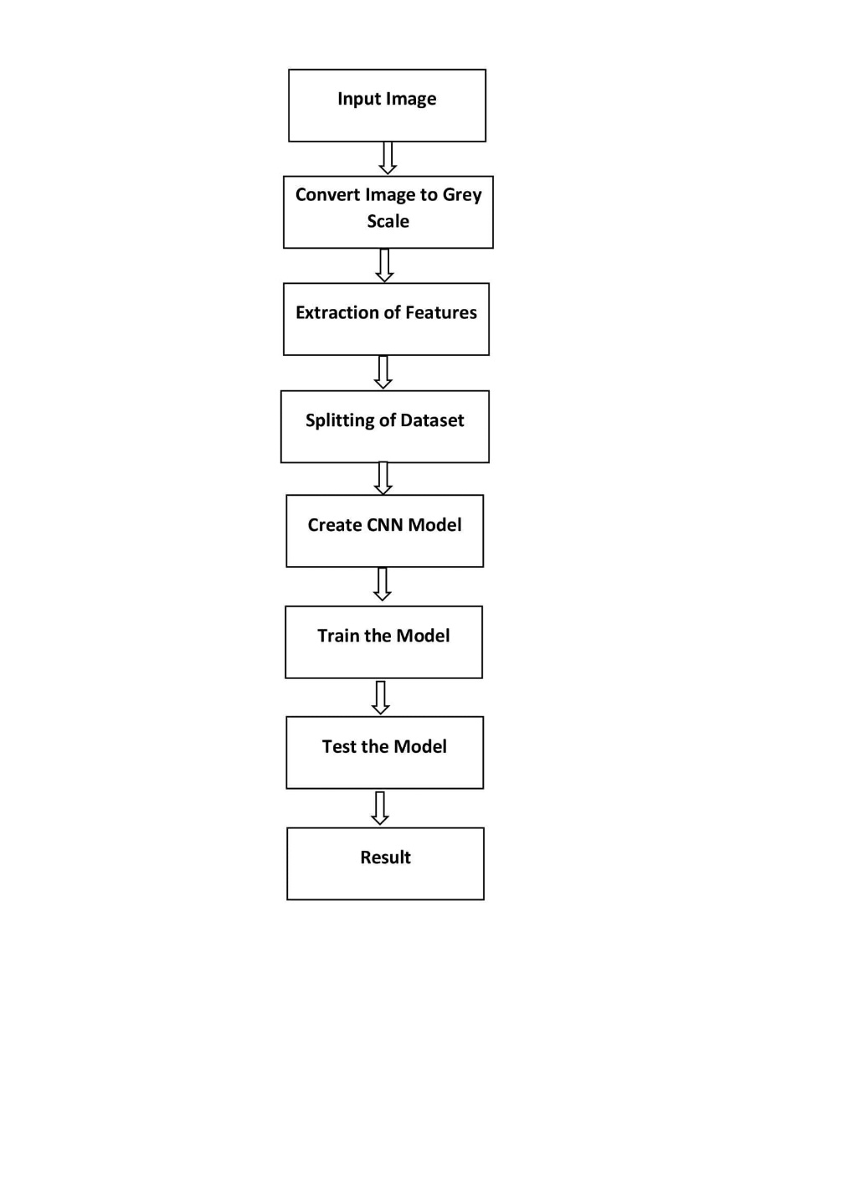

Fig 1: Block diagram – Web application

* 1. **FUNCTIONING AND METHODOLOGY**

1. **HOME PAGE**

The user visits the home page where all the relevant information regarding the pneumonia disease is displayed and the symptoms of the disease is given for the user’s knowledge.

1. **FLASK SERVER**

Flask is a micro web framework written in Python. It is classified as a micro framework because it does not require particular tools or libraries. It acts a local server and renders web pages.

1. **CONVOLUTIONAL NEURAL NETWORK**

The algorithm that we chose to detect pneumonia from chest X-ray images is Convolutional Neural Network. Convolutional Neural Network is a Deep Learning algorithm that takes input and calculates values from one layer to another with appropriate weights and produces an output. The basic idea is that CNN tries to identify features and patterns from the input and predicts the output. CNN strives to mimic the neuron connectivity of the human brain. CNN is used to reduce the input into a form without losing salient features to make a good prediction.

We initialize the CNN model and give the augmented image dataset as the input to it. The Convolution layer detects features from the images and produces feature maps. The feature maps are then fed to the pooling layer, where the convolved features are furthermore reduced in dimension for faster computation. The pooling can be done in two ways, Max pooling where the maximum value is obtained from the feature map, and Average Pooling where the average is obtained. The Flatten layer then reduces the high dimensional data to a column vector. The column vector is then given to the hidden layers where the units in the layer, process the data and produce output by an activation function. At last, the output layer predicts the result.

**CHAPTER 4**

1. **Implementation and Results**
   1. **Implementation**

The app python file is run and the flask library acts as the local server and the web application starts to run in the localhost. Once the user visits the web page, information about pneumonia disease is displayed with additional reference links. Images explaining the symptoms are rendered in the web page. There will be a image input option to get the user’s Chest X-ray image which can be in .jpg, .png, .jpeg formats. Once the user uploads the image, it is previewed to the user and a predict button pops up. Upon clicking the predict button the image is stored in the local machine which is then given to the saved CNN model as input and the prediction results are returned to the webpage.

* 1. **RESULTS**

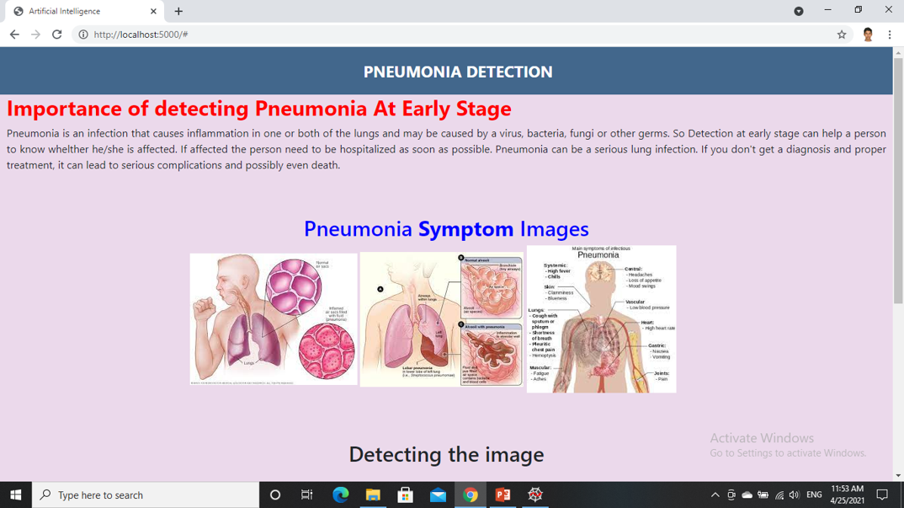

Fig 2: Index Page – Web application

(The webpage displays information and images about pneumonia)

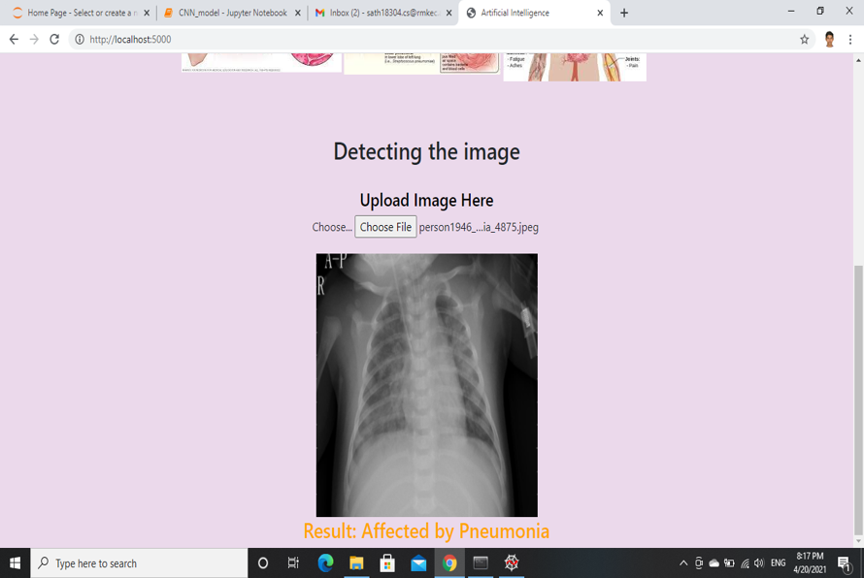

Fig 3: Image Preview and Result(1)– Web application

(The preview of the X-ray image and the result ‘Affected by Pneumonia’ is displayed)

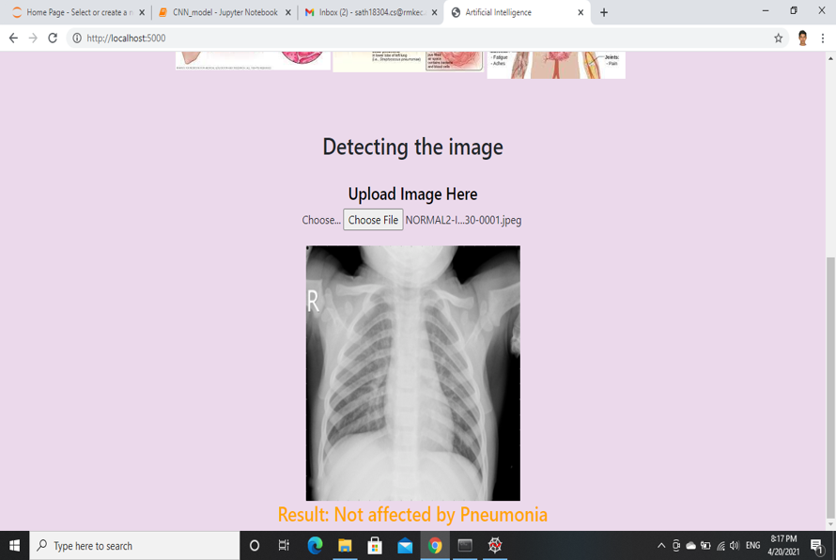

Fig 4: Image Preview and Result – Web application

(The preview of the X-ray image and the result ‘Affected by Pneumonia’ is displayed)

**CHAPTER 5**

1. **CODE SNIPPET**
   1. **PYTHON CODE FOR CNN MODEL**

from keras.preprocessing.image import ImageDataGenerator

train_datagen = ImageDataGenerator(rescale = 1./255,shear_range = 0.2,zoom_range = 0.2,horizontal_flip = True)

test_datagen = ImageDataGenerator(rescale = 1./255)

x_train = train_datagen.flow_from_directory("D:/College files/6th Sem/Mini project/chest_xray/train",target_size=(75,75),batch_size= 32,color_mode = "grayscale", class_mode='binary')

x_test = test_datagen.flow_from_directory("D:/College files/6th Sem/Mini project/chest_xray/test",target_size=(75,75),batch_size= 32,color_mode = "grayscale", class_mode='binary')

from keras.models import Sequential

from keras.layers import Conv2D, MaxPooling2D, Dense, Dropout, Flatten

model = Sequential()

model.add(Conv2D(64,(3,3), activation='relu', input_shape=(75,75,1)))

model.add(MaxPooling2D(pool_size=(3,3), strides=(2,2)))

model.add(Flatten())

model.add(Dense(units= 512, kernel_initializer="uniform", activation="relu"))

model.add(Dense(units = 256, kernel_initializer="uniform", activation="relu"))

model.add(Dense(units = 1, kernel_initializer="uniform", activation="sigmoid"))

model.compile(optimizer='adam', loss='binary_crossentropy', metrics=['accuracy'])

model.fit_generator(x_train,steps_per_epoch=5216//32, epochs= 10, validation_data=x_test, validation_steps=624//32)

x_train.class_indices

import tensorflow.keras.preprocessing.image

from skimage.transform import resize

def detect(frame):

img = resize(frame,(75,75))

img = tensorflow.keras.preprocessing.image.img_to_array(img)

img = np.expand_dims(img, axis= 0)

if np.max(img)>1:

img = img/255.0

prediction = model.predict(img)

print(prediction)

class_pred = model.predict_classes(img)

print(class_pred)

if class_pred[0]==0:

print("Normal")

else:

print("Pneumonia")

import numpy as np

import cv2

frame = cv2.imread("D:/College files/6th Sem/Mini project/chest_xray/val/PNEUMONIA/person1951_bacteria_4882.jpeg",0)

detect(frame)

* 1. **FLASK APP – PYTHON**

import numpy as np

import os

from keras.models import load_model

from keras.preprocessing import image

import tensorflow as tf

global graph

graph = tf.compat.v1.get_default_graph()

from flask import Flask , request, render_template

from werkzeug.utils import secure_filename

from gevent.pywsgi import WSGIServer

app = Flask(__name__)

model = load_model("cnn_model.h5")

@app.route('/')

def index():

return render_template('index.html',methods=['GET'])

@app.route('/predict',methods = ['GET','POST'])

def upload():

if request.method == "POST":

f = request.files["image"]

basepath = os.path.dirname(__file__)

print("current path", basepath)

filepath = os.path.join(basepath,"uploads",secure_filename(f.filename))

print("upload folder is ", filepath)

f.save(filepath)

img = image.load_img(filepath,target_size = (75,75))

x = image.img_to_array(img)

x = np.expand_dims(x,axis =0)

#with graph.as_default():

preds = model.predict_classes(x)

pred = preds[0][0]

if not pred:

text ="Not Affected by Pneumonia"

else:

text = "Affected by Pneumonia"

print(text)

return text

if __name__ == '__main__':

app.run()

* 1. **HTML**

**INDEX PAGE**

<html>

<head>

<meta charset="UTF-8">

<meta name="viewport" content="width=device-width, initial-scale=1.0">

<meta http-equiv="X-UA-Compatible" content="ie=edge">

<title>Artificial Intelligence</title>

<link href="https://cdn.bootcss.com/bootstrap/4.0.0/css/bootstrap.min.css" rel="stylesheet">

<script src="https://cdn.bootcss.com/popper.js/1.12.9/umd/popper.min.js"></script>

<script src="https://cdn.bootcss.com/jquery/3.3.1/jquery.min.js"></script>

<script src="https://cdn.bootcss.com/bootstrap/4.0.0/js/bootstrap.min.js"></script>

<!--<link href="{{ url_for('static', filename='css/main.css') }}" rel="stylesheet">

<link rel="stylesheet" href="{{url_for('static',filename='css/main6.css')}}"> -->

<style>

.moveright {

text-align:right;

}

.moveleft {

text-align:left;

}

.movecenter{

text-align: center;

}

.movejustify{

text-align: justify;

}

.images{

text-align: center;

padding-right: 3%;

}

.detect{

padding-left: 275px;

padding-right: 200px;

word-spacing: 20px;

}

.button{

background-color:blue;

color:white;

}

div.ex1{

padding:25px;

width:30px;

background-color:yellow;

}

div.ex2{

background-color:rgb(0,191,255);

color:rgb(162,0,175);

padding:35px;

}

.heading_bar{

padding-right: 200px;

padding-top: 10px;

padding-bottom: 10px;

}

.navigation-buttons{

padding-right : 50px;

}

.bg-dark {

background-color: #42678c!important;

}

#result {

color: orange;

}

.head{

position: relative;

left: 150%;

}

</style>

<script>

function pageRedirect(){

window.location.href="https://www.webmd.com/lung/understanding-pneumonia-basics"

}

function pageRedirect2(){

window.location.href="https://en.wikipedia.org/wiki/List_of_ships_sunk_by_icebergs"

}

</script>

</head>

<body style="background-color: rgb(235, 217, 235);">

<nav class="navbar navbar-dark bg-dark">

<div class="container">

<div class="heading_bar">

<a href="#" style="color:white; font-size: x-large;"><strong class="head">PNEUMONIA DETECTION</strong></a>

</div>

</div>

</nav>

<h2 style="color:red" ><strong>Importance of detecting Pneumonia At Early Stage </strong></h2>

<p class="movejustify">Pneumonia is an infection that causes inflammation in one or both of the lungs and may be caused by a virus, bacteria, fungi or other germs. So Detection at early stage can help a person to know whelther he/she is affected . If Affected the person need to be hospitalized as soon as possible.

</p>

<br>

<br>

<h2 class="movecenter" style="color:blue">Pneumonia<strong> Symptom</strong> Images</h2>

<div class="images">

<img src="{{ url_for('static', filename='images/image1.jpg') }}" alt="">

<img src="{{ url_for('static', filename='images/image2.png') }}" alt="">

<img src="{{ url_for('static', filename='images/image3.png') }}" alt="">

</div>

<br>

<br>

<br>

<h2 class="movecenter">

Detecting the image</h2>

</div>

<br>

<h4 class="movecenter" style="color:black">Upload Image Here</h4>

<div class="movecenter">

<form action="http:/localhost:5000/predict" id="upload-file" method="post" enctype="multipart/form-data">

<label for="imageUpload" class="upload-label">

Choose...

</label>

<input type="file" name="image" id="imageUpload" accept=".png, .jpg, .jpeg">

</form>

<div class="image-section" style="display: block;">

<div class="img-preview">

<div id="imagePreview">

</div>

</div>

<div>

<button type="button" class="btn btn-primary btn-lg " id="btn-predict">Predict!</button>

</div>

</div>

<h3 id="result">

<span> </span>

</h3>

</div>

</body>

<footer>

<script src="{{ url_for('static', filename='js/main.js') }}" type="text/javascript"></script>

</footer>

</html>

* 1. **JAVASCRIPT**

$(document).ready(function () {

// Init

$('.image-section').hide();

$('.loader').hide();

$('#result').hide();

// Upload Preview

function readURL(input) {

if (input.files && input.files[0]) {

var reader = new FileReader();

reader.onload = function (e) {

$('#imagePreview').css('background-image', 'url(' + e.target.result + ')');

$('#imagePreview').hide();

$('#imagePreview').fadeIn(650);

}

reader.readAsDataURL(input.files[0]);

}

}

$("#imageUpload").change(function () {

$('.image-section').show();

$('#btn-predict').show();

$('#result').text('');

$('#result').hide();

readURL(this);

});

// Predict

$('#btn-predict').click(function () {

var form_data = new FormData($('#upload-file')[0]);

// Show loading animation

$(this).hide();

$('.loader').show();

// Make prediction by calling api /predict

$.ajax({

type: 'POST',

url: '/predict',

data: form_data,

contentType: false,

cache: false,

processData: false,

async: true,

success: function (data) {

// Get and display the result

$('.loader').hide();

$('#result').fadeIn(600);

$('#result').text(' Result: ' + data);

console.log('Success!');

},

});

});

});

* 1. **CSS**
     1. **main.css**

.img-preview {

width: 256px;

height: 256px;

position: relative;

border: 5px solid #F8F8F8;

box-shadow: 0px 2px 4px 0px rgba(0, 0, 0, 0.1);

margin-top: 1em;

margin-bottom: 1em;

}

.img-preview>div {

width: 100%;

height: 100%;

background-size: 256px 256px;

background-repeat: no-repeat;

background-position: center;

}

input[type="file"] {

display: none;

}

body {

width: 100%;

height:100%;

font-family: 'Open Sans', sans-serif;

background-image:url("https://i.pinimg.com/originals/d5/86/b0/d586b0be0cdd1edd2ea8634e473c7ad9.jpg");

background-position: center;

background-repeat: no-repeat;

background-size: cover;

color: #ffff;

font-size: 18px;

text-align:center;

letter-spacing:1.2px;

}

.upload-label{

display: inline-block;

padding: 12px 30px;

background: #39D2B4;

color: #fff;

font-size: 1em;

transition: all .4s;

cursor: pointer;

}

.upload-label:hover{

background: #34495E;

color: #39D2B4;

}

.loader {

border: 8px solid #f3f3f3; /* Light grey */

border-top: 8px solid #3498db; /* Blue */

border-radius: 50%;

width: 50px;

height: 50px;

animation: spin 1s linear infinite;

}

@keyframes spin {

0% { transform: rotate(0deg); }

100% { transform: rotate(360deg); }

}

* + 1. **main6.css**

.img-preview {

width: 256px;

height: 256px;

position: relative;

border: 5px solid #F8F8F8;

box-shadow: 0px 2px 4px 0px rgba(0, 0, 0, 0.1);

margin-top: 1em;

margin-bottom: 1em;

}

.img-preview>div {

width: 100%;

height:100%;

background-size: 256px 256px;

background-repeat: no-repeat;

background-position: center;

}

input[type="file"] {

display: none;

}

body {

width: 100%;

height:300%;

font-family: 'Open Sans', sans-serif;

background-image:url("https://nuwallpaperhd.info/wp-content/uploads/2019/08/sea-waves-hd-sunset-background-wallpaper.jpg");

background-position: center;

background-repeat: no-repeat;

background-size: cover;

color: #ffff;

font-size: 18px;

text-align:center;

letter-spacing:1.2px;

}

.upload-label{

display: inline-block;

padding: 12px 30px;

background: blue;

color: #fff;

font-size: 1em;

transition: all .4s;

cursor: pointer;

}

.upload-label:hover{

background: #34495E;

color: #39D2B4;

}

.loader {

border: 8px solid #f3f3f3; /* Light grey */

border-top: 8px solid #3498db; /* Blue */

border-radius: 50%;

width: 50px;

height: 50px;

animation: spin 1s linear infinite;

}

@keyframes spin {

0% { transform: rotate(0deg); }

100% { transform: rotate(360deg); }

}

**CHAPTER 6**

1. **Conclusion and Future enhancement**
   1. **Conclusion**

This project dealt with designing and developing a web based application which can easily be accessed by any common man from anywhere. The application can be very helpful to doctors as well as patients to easily detect and diagnose pneumonia quickly and efficiently.

* 1. **Future Enhancement**
* The CNN model built has an accuracy of 95% but still it can be improved.
* Adding more layers of convolution can make the model predict better.
* The image resolution can be increased to get better results.
* More augmented images make the model to learn more efficiently

**REFERENCES**

1. Rajpurkar P, Irvin J, Ball RL, Zhu K, Yang B, Mehta H, et al. (2018) Deep learning for chest radiograph diagnosis: A retrospective comparison of the CheXNet algorithm to practicing radiologists. PLoS Med 15(11): e1002686. <https://doi.org/10.1371/journal.pmed.1002686>
2. Okeke Stephen, Mangal Sain, Uchenna Joseph Maduh, Do-Un Jeong, "An Efficient Deep Learning Approach to Pneumonia Classification in Healthcare", *Journal of Healthcare Engineering*, vol. 2019, Article ID 4180949, 7 pages, 2019. <https://doi.org/10.1155/2019/4180949>
3. Begg, R. ‘A Comparison of Neural Networks and Support Vector Machines for Recognizing Young-Old Gait Patterns’ ISBN: 0-7803-8162-9 Publishedin**:**TENCON 2003. <https://ieeexplore.ieee.org/document/1273344>
4. Daniel S. Kermany, Michael Goldbaum, Wenjia Cai ‘Identifying Medical Diagnoses and Treatable Diseases by Image-Based Deep Learning’ Cell Volume 172, Issue 5, P1122-1131.E9, February 22, 2018. <https://doi.org/10.1016/j.cell.2018.02.010>
5. Kalyani Kadam, Dr.Swati Ahirrao, Harbir Kaur ,Dr. Shraddha Phansalkar ,Dr.Ambika Pawar ‘Deep Learning Approach For Prediction Of Pneumonia’ International Journal Of Scientific & Technology Research Volume 8, Issue 10, October 2019 Issn 2277-8616
6. D. Varshni, K. Thakral, L. Agarwal, R. Nijhawan and A. Mittal, "Pneumonia Detection Using CNN based Feature Extraction," 2019 IEEE International Conference on Electrical, Computer and Communication Technologies (ICECCT), 2019, pp. 1-7, doi: 10.1109/ICECCT.2019.8869364.
7. Thakur S., Goplani Y., Arora S., Upadhyay R., Sharma G. (2021) Chest X-Ray Images Based Automated Detection of Pneumonia Using Transfer Learning and CNN. In: Bansal P., Tushir M., Balas V., Srivastava R. (eds) Proceedings of International Conference on Artificial Intelligence and Applications. Advances in Intelligent Systems and Computing, vol 1164. Springer, Singapore. First Online:02 July 2020 <https://doi.org/10.1007/978-981-15-4992-2_31>
8. S. Roshini, R. Sanjana, K. B. Ranjith, and M. Karthick, “Pneumonia Detection from Chest X-ray Using Mask R-CNN”, *IJRESM*, vol. 4, no. 3, pp. 82–83, Mar. 2021.
9. T. Gabruseva, D. Poplavskiy and A. Kalinin, "Deep Learning for Automatic Pneumonia Detection," 2020 IEEE/CVF Conference on Computer Vision and Pattern Recognition Workshops (CVPRW), 2020, pp. 1436-1443, doi: 10.1109/CVPRW50498.2020.00183.
10. H. Sharma, J. S. Jain, P. Bansal and S. Gupta, "Feature Extraction and Classification of Chest X-Ray Images Using CNN to Detect Pneumonia," 2020 10th International Conference on Cloud Computing, Data Science & Engineering (Confluence), 2020, pp. 227-231, doi: 10.1109/Confluence47617.2020.9057809.